Atlanta Population

Q1.

MongoDB Enterprise atlas-jsun6x-shard-0:PRIMARY> db.zipcodes.find({city:"ATLANTA",state:"GA"})

{ "_id" : "30303", "city" : "ATLANTA", "loc" : [ -84.388846, 33.752504 ], "pop" : 1845, "state" : "GA" }

{ "_id" : "30305", "city" : "ATLANTA", "loc" : [ -84.385145, 33.831963 ], "pop" : 19122, "state" : "GA" }

{ "_id" : "30306", "city" : "ATLANTA", "loc" : [ -84.351418, 33.786027 ], "pop" : 20081, "state" : "GA" }

{ "_id" : "30307", "city" : "ATLANTA", "loc" : [ -84.335957, 33.769138 ], "pop" : 16330, "state" : "GA" }

{ "_id" : "30308", "city" : "ATLANTA", "loc" : [ -84.375744, 33.771839 ], "pop" : 8549, "state" : "GA" }

{ "_id" : "30309", "city" : "ATLANTA", "loc" : [ -84.388338, 33.798407 ], "pop" : 14766, "state" : "GA" }

{ "_id" : "30310", "city" : "ATLANTA", "loc" : [ -84.423173, 33.727849 ], "pop" : 34017, "state" : "GA" }

{ "_id" : "30311", "city" : "ATLANTA", "loc" : [ -84.470219, 33.722957 ], "pop" : 34880, "state" : "GA" }

{ "_id" : "30312", "city" : "ATLANTA", "loc" : [ -84.378125, 33.746749 ], "pop" : 17683, "state" : "GA" }

{ "_id" : "30313", "city" : "ATLANTA", "loc" : [ -84.39352, 33.76825 ], "pop" : 8038, "state" : "GA" }

{ "_id" : "30314", "city" : "ATLANTA", "loc" : [ -84.425546, 33.756103 ], "pop" : 26649, "state" : "GA" }

{ "_id" : "30315", "city" : "ATLANTA", "loc" : [ -84.380771, 33.705062 ], "pop" : 41061, "state" : "GA" }

{ "_id" : "30316", "city" : "ATLANTA", "loc" : [ -84.333913, 33.721686 ], "pop" : 34668, "state" : "GA" }

{ "_id" : "30317", "city" : "ATLANTA", "loc" : [ -84.31685, 33.749788 ], "pop" : 16395, "state" : "GA" }

{ "_id" : "30318", "city" : "ATLANTA", "loc" : [ -84.445432, 33.786454 ], "pop" : 53894, "state" : "GA" }

{ "_id" : "30319", "city" : "ATLANTA", "loc" : [ -84.335091, 33.868728 ], "pop" : 32138, "state" : "GA" }

{ "_id" : "30324", "city" : "ATLANTA", "loc" : [ -84.354867, 33.820609 ], "pop" : 15044, "state" : "GA" }

{ "_id" : "30326", "city" : "ATLANTA", "loc" : [ -84.358232, 33.848168 ], "pop" : 125, "state" : "GA" }

{ "_id" : "30327", "city" : "ATLANTA", "loc" : [ -84.419966, 33.862723 ], "pop" : 18467, "state" : "GA" }

{ "_id" : "30329", "city" : "ATLANTA", "loc" : [ -84.321402, 33.823555 ], "pop" : 17013, "state" : "GA" }

Type "it" for more

MongoDB Enterprise atlas-jsun6x-shard-0:PRIMARY>

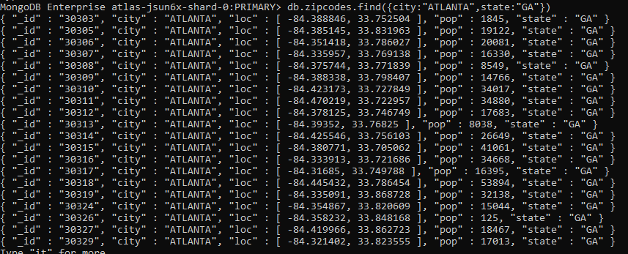

Q2

MongoDB Enterprise atlas-jsun6x-shard-0:PRIMARY> db.zipcodes.aggregate([{$match:{city:"ATLANTA",state:"GA"}}])

{ "_id" : "30303", "city" : "ATLANTA", "loc" : [ -84.388846, 33.752504 ], "pop" : 1845, "state" : "GA" }

{ "_id" : "30305", "city" : "ATLANTA", "loc" : [ -84.385145, 33.831963 ], "pop" : 19122, "state" : "GA" }

{ "_id" : "30306", "city" : "ATLANTA", "loc" : [ -84.351418, 33.786027 ], "pop" : 20081, "state" : "GA" }

{ "_id" : "30307", "city" : "ATLANTA", "loc" : [ -84.335957, 33.769138 ], "pop" : 16330, "state" : "GA" }

{ "_id" : "30308", "city" : "ATLANTA", "loc" : [ -84.375744, 33.771839 ], "pop" : 8549, "state" : "GA" }

{ "_id" : "30309", "city" : "ATLANTA", "loc" : [ -84.388338, 33.798407 ], "pop" : 14766, "state" : "GA" }

{ "_id" : "30310", "city" : "ATLANTA", "loc" : [ -84.423173, 33.727849 ], "pop" : 34017, "state" : "GA" }

{ "_id" : "30311", "city" : "ATLANTA", "loc" : [ -84.470219, 33.722957 ], "pop" : 34880, "state" : "GA" }

{ "_id" : "30312", "city" : "ATLANTA", "loc" : [ -84.378125, 33.746749 ], "pop" : 17683, "state" : "GA" }

{ "_id" : "30313", "city" : "ATLANTA", "loc" : [ -84.39352, 33.76825 ], "pop" : 8038, "state" : "GA" }

{ "_id" : "30314", "city" : "ATLANTA", "loc" : [ -84.425546, 33.756103 ], "pop" : 26649, "state" : "GA" }

{ "_id" : "30315", "city" : "ATLANTA", "loc" : [ -84.380771, 33.705062 ], "pop" : 41061, "state" : "GA" }

{ "_id" : "30316", "city" : "ATLANTA", "loc" : [ -84.333913, 33.721686 ], "pop" : 34668, "state" : "GA" }

{ "_id" : "30317", "city" : "ATLANTA", "loc" : [ -84.31685, 33.749788 ], "pop" : 16395, "state" : "GA" }

{ "_id" : "30318", "city" : "ATLANTA", "loc" : [ -84.445432, 33.786454 ], "pop" : 53894, "state" : "GA" }

{ "_id" : "30319", "city" : "ATLANTA", "loc" : [ -84.335091, 33.868728 ], "pop" : 32138, "state" : "GA" }

{ "_id" : "30324", "city" : "ATLANTA", "loc" : [ -84.354867, 33.820609 ], "pop" : 15044, "state" : "GA" }

{ "_id" : "30326", "city" : "ATLANTA", "loc" : [ -84.358232, 33.848168 ], "pop" : 125, "state" : "GA" }

{ "_id" : "30327", "city" : "ATLANTA", "loc" : [ -84.419966, 33.862723 ], "pop" : 18467, "state" : "GA" }

{ "_id" : "30329", "city" : "ATLANTA", "loc" : [ -84.321402, 33.823555 ], "pop" : 17013, "state" : "GA" }

Type "it" for more

MongoDB Enterprise atlas-jsun6x-shard-0:PRIMARY>

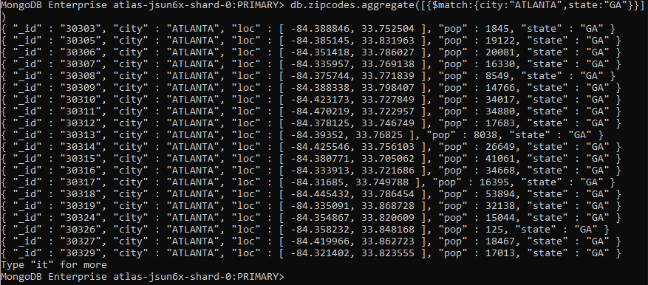

Q3.

Q4.

Populations by state:

Q1. use aggregate to calculate the total population for each state

MongoDB Enterprise atlas-jsun6x-shard-0:PRIMARY> db.zipcodes.aggregate( [ { $group: { _id: "$state", totalPop: { $sum: "$pop" } } } ] )

{ "_id" : "MT", "totalPop" : 798948 }

{ "_id" : "AK", "totalPop" : 544698 }

{ "_id" : "MA", "totalPop" : 6016425 }

{ "_id" : "SC", "totalPop" : 3486703 }

{ "_id" : "TN", "totalPop" : 4876457 }

{ "_id" : "OH", "totalPop" : 10846517 }

{ "_id" : "DC", "totalPop" : 606900 }

{ "_id" : "MD", "totalPop" : 4781379 }

{ "_id" : "WI", "totalPop" : 4891769 }

{ "_id" : "UT", "totalPop" : 1722850 }

{ "_id" : "MO", "totalPop" : 5110648 }

{ "_id" : "CO", "totalPop" : 3293755 }

{ "_id" : "CA", "totalPop" : 29754890 }

{ "_id" : "KY", "totalPop" : 3675484 }

{ "_id" : "MI", "totalPop" : 9295297 }

{ "_id" : "NJ", "totalPop" : 7730188 }

{ "_id" : "ID", "totalPop" : 1006749 }

{ "_id" : "CT", "totalPop" : 3287116 }

{ "_id" : "WV", "totalPop" : 1793146 }

{ "_id" : "TX", "totalPop" : 16984601 }

Type "it" for more

MongoDB Enterprise atlas-jsun6x-shard-0:PRIMARY>

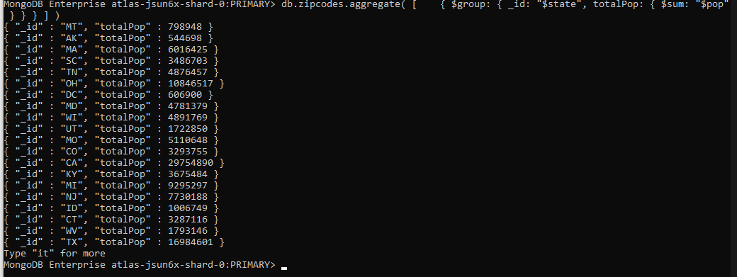

Q2. Sort the results by pop, highest first

MongoDB Enterprise atlas-jsun6x-shard-0:PRIMARY> db.zipcodes.find().sort({pop:-1})

{ "_id" : "60623", "city" : "CHICAGO", "loc" : [ -87.7157, 41.849015 ], "pop" : 112047, "state" : "IL" }

{ "_id" : "11226", "city" : "BROOKLYN", "loc" : [ -73.956985, 40.646694 ], "pop" : 111396, "state" : "NY" }

{ "_id" : "10021", "city" : "NEW YORK", "loc" : [ -73.958805, 40.768476 ], "pop" : 106564, "state" : "NY" }

{ "_id" : "10025", "city" : "NEW YORK", "loc" : [ -73.968312, 40.797466 ], "pop" : 100027, "state" : "NY" }

{ "_id" : "90201", "city" : "BELL GARDENS", "loc" : [ -118.17205, 33.969177 ], "pop" : 99568, "state" : "CA" }

{ "_id" : "60617", "city" : "CHICAGO", "loc" : [ -87.556012, 41.725743 ], "pop" : 98612, "state" : "IL" }

{ "_id" : "90011", "city" : "LOS ANGELES", "loc" : [ -118.258189, 34.007856 ], "pop" : 96074, "state" : "CA" }

{ "_id" : "60647", "city" : "CHICAGO", "loc" : [ -87.704322, 41.920903 ], "pop" : 95971, "state" : "IL" }

{ "_id" : "60628", "city" : "CHICAGO", "loc" : [ -87.624277, 41.693443 ], "pop" : 94317, "state" : "IL" }

{ "_id" : "90650", "city" : "NORWALK", "loc" : [ -118.081767, 33.90564 ], "pop" : 94188, "state" : "CA" }

{ "_id" : "60620", "city" : "CHICAGO", "loc" : [ -87.654251, 41.741119 ], "pop" : 92005, "state" : "IL" }

{ "_id" : "60629", "city" : "CHICAGO", "loc" : [ -87.706936, 41.778149 ], "pop" : 91814, "state" : "IL" }

{ "_id" : "60609", "city" : "CHICAGO", "loc" : [ -87.653279, 41.809721 ], "pop" : 89762, "state" : "IL" }

{ "_id" : "60618", "city" : "CHICAGO", "loc" : [ -87.704214, 41.946401 ], "pop" : 88377, "state" : "IL" }

{ "_id" : "11373", "city" : "JACKSON HEIGHTS", "loc" : [ -73.878551, 40.740388 ], "pop" : 88241, "state" : "NY" }

{ "_id" : "91331", "city" : "ARLETA", "loc" : [ -118.420692, 34.258081 ], "pop" : 88114, "state" : "CA" }

{ "_id" : "11212", "city" : "BROOKLYN", "loc" : [ -73.914483, 40.662474 ], "pop" : 87079, "state" : "NY" }

{ "_id" : "90280", "city" : "SOUTH GATE", "loc" : [ -118.201349, 33.94617 ], "pop" : 87026, "state" : "CA" }

{ "_id" : "11385", "city" : "RIDGEWOOD", "loc" : [ -73.896122, 40.703613 ], "pop" : 85732, "state" : "NY" }

{ "_id" : "10467", "city" : "BRONX", "loc" : [ -73.871242, 40.873671 ], "pop" : 85710, "state" : "NY" }

Type "it" for more

MongoDB Enterprise atlas-jsun6x-shard-0:PRIMARY>

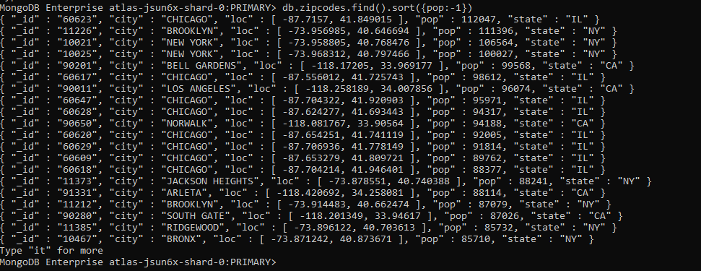

Q3. Limit the results to just the first 3 results, what are the top 3 states in population

MongoDB Enterprise atlas-jsun6x-shard-0:PRIMARY> db.zipcodes.find().sort({pop:-1}).limit(3)

{ "_id" : "60623", "city" : "CHICAGO", "loc" : [ -87.7157, 41.849015 ], "pop" : 112047, "state" : "IL" }

{ "_id" : "11226", "city" : "BROOKLYN", "loc" : [ -73.956985, 40.646694 ], "pop" : 111396, "state" : "NY" }

{ "_id" : "10021", "city" : "NEW YORK", "loc" : [ -73.958805, 40.768476 ], "pop" : 106564, "state" : "NY" }

MongoDB Enterprise atlas-jsun6x-shard-0:PRIMARY>

